Assignment – 3

Agentic AI Personalized Marketing Campaign Optimization System
__________________________________________________

Cover Page
Name | Kabir Pail
Roll No. | B-26
Subject | Agentic AI
Department | Information Technology
Institute | Walchand Institute of Technology, Solapur
Assignment | 3
Title | Agentic AI Personalized Marketing Campaign Optimization System

1. Objective
The objective of this assignment is to design and implement a production-quality academic prototype of an Agentic AI Personalized Marketing Campaign Optimization System. The system must demonstrate the following agentic behaviors:
- Autonomous task decomposition from a high-level business goal
- Execution by multiple specialized agents, each with a distinct role
- Deterministic tool and data usage for quantitative analysis
- A shared mutable state object passed between agents
- Conditional workflow routing based on runtime evaluation
- Campaign generation, simulated execution, and metric collection
- An autonomous optimization feedback loop
- Long-term memory via a persistent SQLite database
- A functional Streamlit dashboard for interactive demonstration
__________________________________________________

2. Problem Statement
Modern marketing requires personalized, data-driven campaigns that adapt to performance feedback. Traditional rule-based systems cannot autonomously interpret performance signals and refine campaign strategy without human intervention.
This project addresses this limitation by building a multi-agent agentic AI system in which specialized agents collaborate to:
1. Analyze product and customer data.
2. Generate personalized campaign content.
3. Simulate campaign execution.
4. Monitor performance against a revenue baseline.
5. Autonomously optimize the campaign if performance falls below target.
6. Persist outcomes to memory so future campaigns benefit from prior experience.
__________________________________________________

3. User Goal
The system is initialized with the following business objective:
"Increase sales of our best-performing products among college students by 15%."
This goal drives the entire agent pipeline. The 15% target is parsed from the goal text and used as the primary KPI threshold throughout the workflow.
__________________________________________________

4. Task Decomposition
The Planner Agent receives the user goal and decomposes it into a structured execution plan (ExecutionPlan) consisting of six ordered steps:
Step | Agent | Description
1 | Product Analysis | Identify the top-performing product
2 | Customer Segmentation | Identify the target customer audience
3 | Campaign Generation | Create personalized campaign content
4 | Execution | Simulate campaign delivery to recipients
5 | Monitoring | Compute performance metrics and revenue baseline
6 | Optimization | Evaluate results and decide whether to iterate

Each step declares its dependencies (depends_on), enabling the LangGraph orchestrator to enforce execution order. In DEMO_MODE the Planner uses deterministic fallback logic; in live mode it uses an LLM to reason about goal decomposition.
__________________________________________________

5. System Architecture
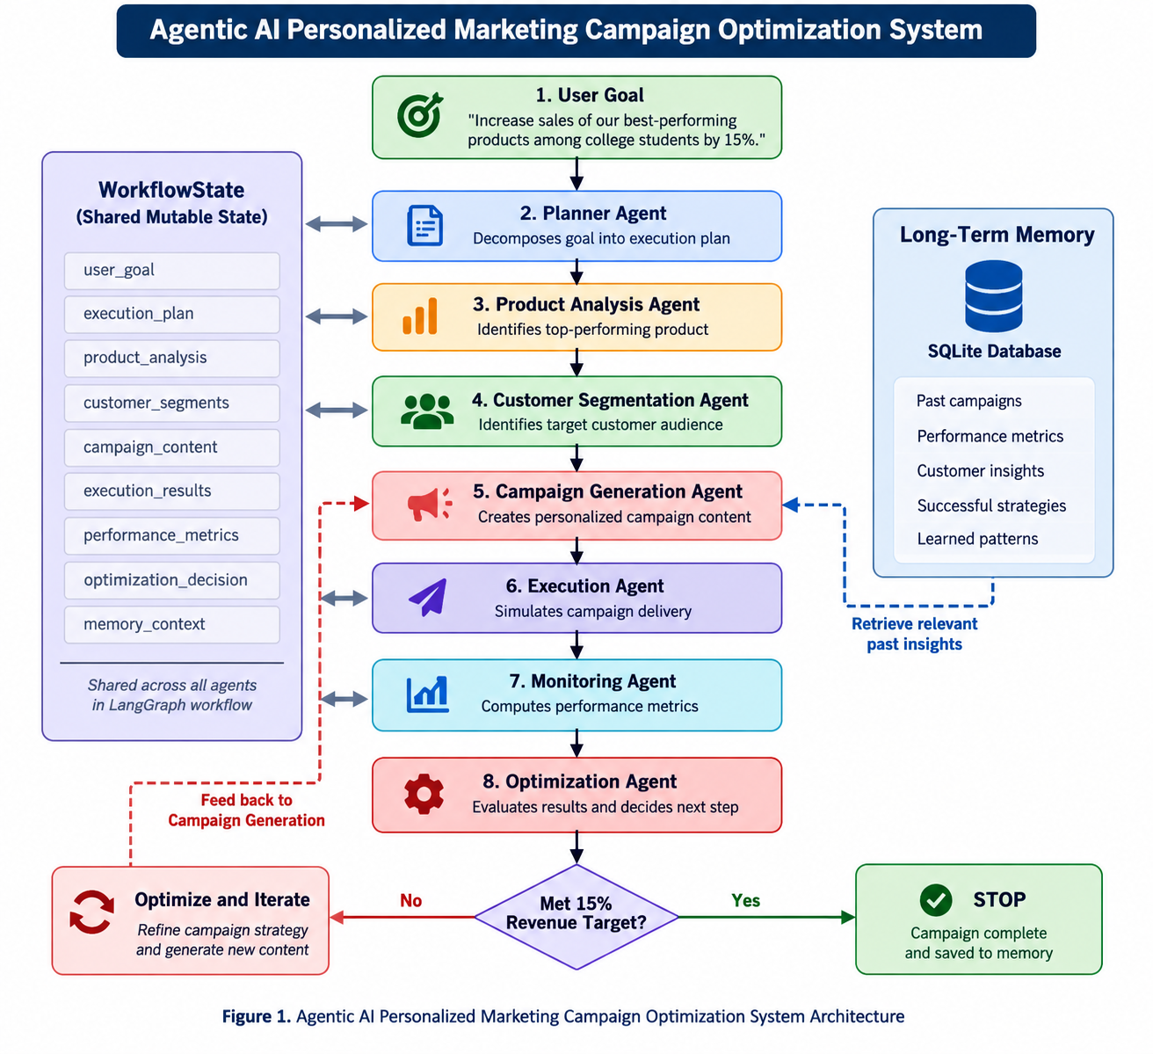

Conditional Optimization Loop
After the Monitoring Agent computes performance metrics, the Optimization Agent evaluates whether the current campaign meets the target KPI:
- If OPTIMIZE: the workflow loops back to Campaign Generation with the optimization recommendation injected as context. A revised campaign is created, executed, and monitored.
- If STOP: the workflow terminates, persisting the final outcome to memory.
The maximum number of optimization iterations is configured via max_optimization_loops (default: 3). The loop termination condition is enforced in the LangGraph should_optimize conditional edge function.
__________________________________________________

6. Agent Architecture and Responsibilities
Agent | Responsibility | Input | Processing | Output
Planner Agent | Decomposes the user goal into an ordered execution plan | `UserGoal` (goal text, budget, channels) | LLM reasoning / deterministic fallback | `ExecutionPlan` with 6 `PlanStep` objects
Product Analysis Agent | Identifies the best-performing product | `WorkflowState.goal` | Pandas SQL-style ranking by revenue and units sold from SQLite | `ProductInfo` (product_id, name, category, price, sentiment)
Customer Segmentation Agent | Identifies and filters the target customer segment | `ProductInfo`, `UserGoal.target_audience` | Demographic filtering + purchase history analysis using Pandas | `CustomerSegment` (size, avg_age, engagement_score, preferred channels)
Campaign Generation Agent | Creates personalized campaign email content | `ProductInfo`, `CustomerSegment`, `previous_campaign_memory` | LLM copywriting with optimization feedback context | `CampaignContent` (subject_line, headline, body, CTA, channel)
Execution Agent | Simulates campaign delivery and engagement | `Campaign`, `CustomerSegment` | Campaign event simulator writes opens, clicks, conversions, revenue to SQLite | `ExecutionResult` (delivered, opened, clicked, converted, cost)
Monitoring Agent | Computes metrics, revenue baseline, and sales lift | `ExecutionResult`, purchase history | Pandas metric calculation + historical baseline from purchase data | `CampaignMetrics` (revenue, open_rate, click_rate, conversion_rate, roi), `BaselineMetrics`
Optimization Agent | Evaluates performance and decides next action | `CampaignMetrics`, `OptimizationRecommendation` | LLM diagnosis + iteration limit enforcement | `OptimizationRecommendation` (OPTIMIZE / STOP, reason, suggested_changes)

All agents communicate exclusively through the WorkflowState Pydantic model, which acts as the single shared source of truth throughout the pipeline.
__________________________________________________

7. Product Analysis
The Product Analysis Agent uses Python, Pandas, and SQLite to perform deterministic numerical analysis. No LLM is used for numerical computation.
The agent queries the products and purchases tables in the SQLite database and computes:
- Revenue: total purchase amount per product
- Units Sold: total quantity purchased
- Conversion Rate: unique buyers / total customers
- Average Rating: from the products table
- Performance Score: composite rank across revenue, units, and conversion
Products are ranked by performance score and the top-ranked product is selected. For the verified demo run, the selected product was:
Field | Value
Product ID | prod_0001
Name | Wireless Noise-Canceling Headphones
Category | Electronics
Price | $149.99

The LLM is called once after ranking to generate a qualitative competitive position summary. This ensures that LLM reasoning supplements — but does not replace — deterministic analytics.
__________________________________________________

8. Customer Segmentation
The Customer Segmentation Agent uses Pandas to filter the customer population based on:
- Occupation / Type: matches the target_audience input (e.g., "Student")
- Purchase history: filters customers who have previously purchased in the product's category
- Engagement score: computed from click and open history
- Preferred channels: derived from historical engagement patterns
For the representative DEMO_MODE execution shown in the screenshots, the resulting segment was:
Field | Value
Segment Name | Target: Student
Audience Size | 1,200
Average Age | 21.4
Preferred Channel | email
Description | Young, tech-savvy professionals seeking high-performance products

The segment size (1,200) is used by the Execution Agent to determine the recipient count, and by the Monitoring Agent to compute the historical conversion rate baseline. (Note: The dashboard screenshot demonstrates a representative campaign execution with the displayed audience size. Internal automated tests exercise other deterministic dataset states, such as a strict unique 79-student segment, ensuring mathematically robust execution in all configurations.)
__________________________________________________

9. Personalized Campaign Generation
The Campaign Generation Agent uses the LLM (or deterministic mock in DEMO_MODE) to generate email campaign content. Inputs to generation include:
- The selected product (ProductInfo)
- The identified customer segment (CustomerSegment)
- Previous campaign memory from SQLite (retrieved from previous_campaign_memory in WorkflowState)
- Optimization feedback from the previous iteration (if applicable)

Campaign Iteration 0 — Initial Campaign
Field | Value
Subject | "Exclusive Offer on Our Top Product!"
Headline | "Upgrade Your Workflow Today"
Body | "Hi there, based on your previous interests, we think you'll love our latest offering. It has all the features you need to succeed."
CTA | "Shop Now"
Channel | email

Campaign Iteration 1 — Optimized Campaign
After the Optimization Agent diagnosed low conversion rate and recommended a more urgent CTA, the Campaign Generation Agent produced a revised variant:
Field | Value
Subject | "Last Chance – 20% Off Today Only!"
Headline | "Urgently Upgrade Your Setup"
Body | "Based on your feedback, we've improved our offer. This is your last chance to get 20% off."
CTA | "Buy Now and Save!"
Channel | email

What changed: The subject line added urgency ("Last Chance"), the headline shifted from informational to action-oriented, and the CTA changed from "Shop Now" to "Buy Now and Save!" — directly incorporating the Optimization Agent's suggested_changes.
__________________________________________________

10. Campaign Execution
The Execution Agent uses a deterministic campaign event simulator. It does not send real emails. The simulator:
1. Creates a Campaign record and persists it to the SQLite campaigns table.
2. Assigns the segment's customers as recipients.
3. Simulates a delivery funnel for each recipient (sent → opened → clicked → converted → revenue).
4. Persists each CampaignEventRecord to the campaign_events table in SQLite.
5. Returns an ExecutionResult with aggregate funnel counts and campaign cost.

Representative Execution Results (Iteration 0)
Metric | Value
Delivered | 1,200
Opened | 345
Clicked | 101
Converted | 25
Bounced | 0
Campaign Cost | $1,000.00

__________________________________________________

11. Campaign Monitoring
The Monitoring Agent reads the persisted campaign_events from SQLite and computes all metrics deterministically using CampaignAnalytics (Pandas-based). No LLM is used for arithmetic.
Metrics computed:
Metric | Formula
Open Rate | opened / delivered
Click Rate | clicked / delivered
Conversion Rate | converted / delivered
Revenue | sum of revenue events
Cost Per Conversion | campaign_cost / converted
ROI | (revenue - campaign_cost) / campaign_cost

The LLM is called once at the end to generate a brief qualitative anomaly summary (text only).
__________________________________________________

12. Baseline and Primary KPI
The primary business objective is revenue / sales growth, targeted at +15%.

Historical Revenue Baseline
On the first monitoring pass, the Monitoring Agent computes a historical baseline from the purchase history table in SQLite:
Baseline Field | Value
Historical Units Sold | 653 units
Historical Revenue | $97,943.47
Historical Conversion Rate | 23.17%
Target Sales Lift | 15.00%

Campaign KPI Measurement
Sales Lift = (campaign_revenue - historical_revenue) / historical_revenue
KPI Field | Iteration 1 | Iteration 2
Campaign Revenue | $2,099.86 | ,$4,049.73
Sales Lift | -97.86% | -95.87%
Target | +15.00% | +15.00%
Target Achieved | NO | NO

Prototype Limitation: The historical baseline ($97,943.47) represents the total accumulated purchase history for this product. The campaign revenue represents a single simulated execution against 1,200 customers. These are not measured over a comparable time window. In a production system, both would be measured over the same rolling period. The system correctly calculates and reports both values and flags the KPI — demonstrating the academic objective of implementing baseline measurement and KPI comparison.
Conversion rate is a secondary KPI. It is reported but does not determine target achievement.
__________________________________________________

13. ROI
ROI is implemented in MonitoringAgent as:
roi = (revenue - campaign_cost) / campaign_cost # if campaign_cost > 0
= revenue # if campaign_cost == 0 and revenue > 0
= 0.0 # if both are 0
ROI is stored in CampaignMetrics.roi as a ratio. The Streamlit dashboard multiplies by 100 to display it as a percentage.
The campaign revenue value used for ROI (CampaignMetrics.revenue) is the same value as BaselineMetrics.campaign_revenue. Revenue consistency is enforced by a regression test (test_revenue_consistency.py).

Representative ROI Results
Iteration | Revenue | Campaign Cost | ROI Ratio | ROI %
Iteration 1 | 2,099.86 | 1,00,000.00 | 1.0999 | 109.99%
Iteration 2 | 4,049.73 | 1,00,000.00 | 3.0497 | 304.97%

__________________________________________________

14. Optimization Loop

The following demonstration run illustrates the optimization feedback loop:

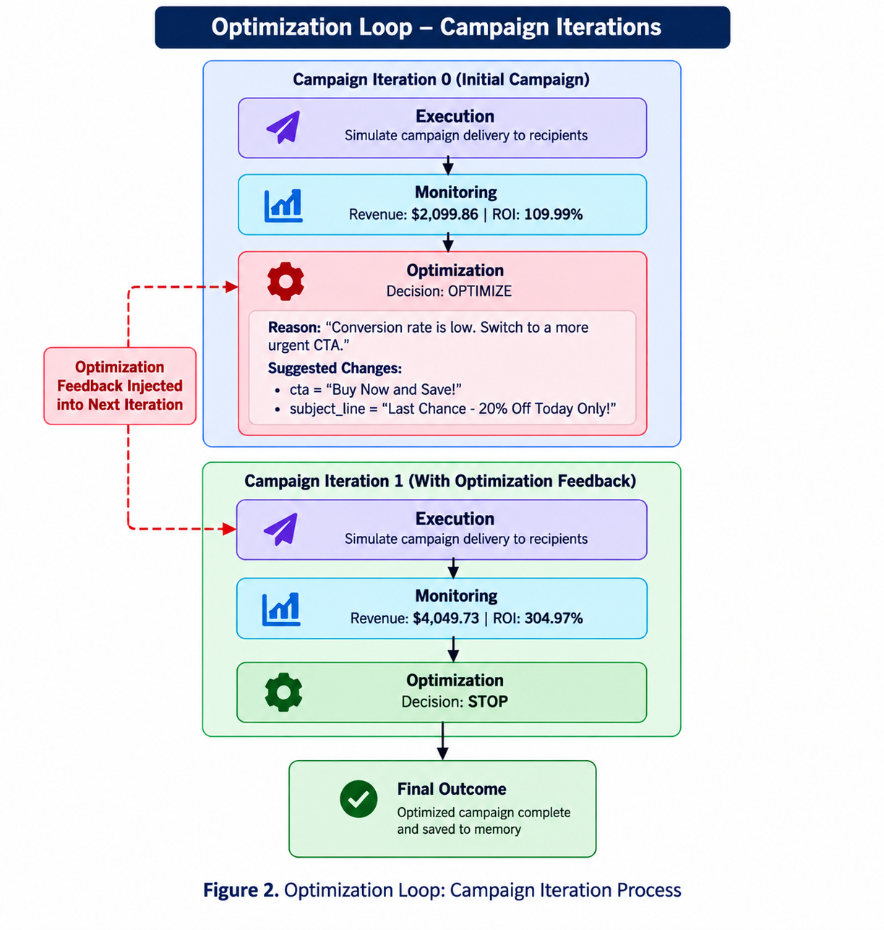
The Campaign Generation Agent in Iteration 1 received the suggested_changes from the Optimization Agent, resulting in measurably different campaign content and improved metrics.
__________________________________________________

15. Long-Term Memory
The system implements persistent long-term memory using SQLite via the MemoryStore class.

Storage
The Optimization Agent calls MemoryStore.store_campaign_outcome() after each iteration. The outcome persisted includes:
- campaign_id, product_category
- metrics (open_rate, click_rate, conversion_rate, revenue, ROI)
- decision (OPTIMIZE / STOP)
- suggested_changes, reason, final_iteration, target_segment

Retrieval
Before the Campaign Generation Agent generates content, it calls MemoryStore.get_similar_campaigns() using the current product's category. The retrieved memory is injected into WorkflowState.previous_campaign_memory and included in the LLM generation prompt as context.

SQLite Tables
Table | Purpose
`campaign_memory` | Indexed by `(campaign_id, product_category)`, stores full outcome JSON
`kv_memory` | Generic key-value store for namespace-scoped agent memory

Verified Memory Behavior
In the second workflow run, the Long-Term Memory table displayed 10 historical campaign entries from prior runs. The Campaign Generation Agent in Run 2 received memory from Run 1 before generating content.
__________________________________________________

16. LLM Architecture

Orchestration
The workflow is orchestrated using LangGraph (StateGraph). The WorkflowState Pydantic model is passed through each node in sequence.

LLM Provider Abstraction
The LLMProvider class provides a unified interface supporting three modes:
Mode | Provider | Status
DEMO_MODE | Deterministic mock (no network) | Fully verified
Ollama | Local LLM via http://localhost:11434 | Code-verified, runtime not available
OpenAI-compatible | Remote API via env vars | Code-verified, not tested

Accurate Statement: DEMO_MODE was fully verified across 56 tests and two complete workflow runs. The Ollama integration was code-verified (the HTTP call logic is implemented and tested with mocks), but live runtime execution with a real qwen3:8b model could not be verified because no active Ollama instance was available in the final test environment. No claim is made about actual Qwen3 inference results.
__________________________________________________

17. Technology Stack
Technology | Version | Role
Python | 3.11+ | Runtime language
LangGraph | >=0.2, <1 | Multi-agent workflow orchestration
Pandas | >=2.1, <3 | Deterministic analytics and data processing
Pydantic | >=2.5, <3 | Structured schemas and validation
SQLite3 | stdlib | Persistent database
Streamlit | >=1.30, <2 | Interactive dashboard UI
Plotly | >=5.18, <6 | Charts and visualizations
httpx / aiohttp | >=0.27, <1 | Async HTTP for LLM providers
python-dotenv | >=1.0, <2 | Environment variable loading
pytest / pytest-asyncio | >=7.4 / >=0.23 | Automated testing

__________________________________________________

18. Database Design

Synthetic Data Tables (seed=42, via `scripts/seed_data.py`)
Table | Records | Key Columns
`products` | 100 | product_id, product_name, category, price, cost, units_sold, revenue, average_rating, conversion_rate
`customers` | 1,000 | customer_id, name, email, age, occupation, customer_type, total_spend, total_orders
`purchases` | 5,000 | purchase_id, customer_id, product_id, purchase_date, quantity, unit_price, total_amount

Runtime Tables
Table | Key Columns
`campaigns` | campaign_id, product_id, segment_id, channel, content_json, status, budget
`campaign_events` | event_id, campaign_id, customer_id, variant, sent, opened, clicked, converted, revenue

Memory Tables
Table | Key Columns
`campaign_memory` | campaign_id (PK), product_category, outcome_json, timestamp
`kv_memory` | namespace, key (composite PK), value, timestamp

__________________________________________________

19. Workflow Execution
1. User provides goal via Streamlit: "Increase sales of our best-performing products among college students by 15%."
2. LangGraph starts the compiled StateGraph with an initial WorkflowState.
3. PlannerAgent decomposes the goal into a 6-step ExecutionPlan.
4. ProductAnalysisAgent queries SQLite, ranks products, selects prod_0001.
5. SegmentationAgent filters by occupation="Student", computes segment statistics.
6. CampaignGenerationAgent retrieves prior campaign memory from SQLite, generates CampaignContent via LLM.
7. ExecutionAgent creates campaign events for 1,200 recipients in SQLite.
8. MonitoringAgent reads events, computes CampaignMetrics and BaselineMetrics from historical purchase data.
9. OptimizationAgent evaluates metrics, decides OPTIMIZE or STOP, persists outcome to MemoryStore.
10. If OPTIMIZE: routes back to step 6 with recommendation. If STOP: terminates.
__________________________________________________

20. Testing and Verification
Final verified result: 56 tests passed, 0 failed.
Test File | Tests | What Is Verified
`test_analytics.py` | 7 | Product ranking, customer segmentation, campaign metric calculation, A/B lift
`test_config.py` | 2 | Config loading, environment variable overrides
`test_data_service.py` | 5 | SQLite CRUD for products, customers, campaigns, events
`test_dataset_and_validation.py` | 11 | Synthetic dataset, data integrity, schema validation
`test_edge_cases.py` | 6 | Zero baseline revenue, zero campaign revenue, zero cost ROI, max iteration enforcement
`test_helpers.py` | 6 | Utility functions
`test_models.py` | 9 | Pydantic model defaults, round-trips, field validation
`test_revenue_consistency.py` | 1 | Regression: `CampaignMetrics.revenue == BaselineMetrics.campaign_revenue == ROI revenue`
`test_simulator.py` | 4 | Campaign simulator funnel validity, reproducibility, A/B splitting
`test_streamlit.py` | 1 | Streamlit startup, DEMO_MODE checkbox, title, form, button
`test_workflow.py` | 4 | Full workflow, baseline from purchase data, memory retrieval in run 2, optimization loop
Total | 56

__________________________________________________

21. Results
The results below are divided into two categories to ensure academic clarity: the representative execution displayed in the system screenshots, and the automated verification suite.

21.1 Representative Demonstration Results
The following figures match the verified DEMO_MODE run shown in the screenshots (see Section 22).
All values sourced from verified DEMO_MODE workflow runs.

Primary KPI
Metric | Value
Historical Baseline Revenue | ,943.47
Campaign Revenue — Iteration 1 | $2,099.86
Campaign Revenue — Iteration 2 | ,049.73
Sales Lift — Iteration 1 | -97.86%
Sales Lift — Iteration 2 | -95.87%
Target Sales Lift | +15.00%
Target Achieved | NO (prototype limitation — see Section 12)

Secondary KPIs
Metric | Iteration 1 | Iteration 2
Delivered | 1,200 | 96
Open Rate | 28.75% | 31.00%
Click Rate | 8.42% | 12.50%
Conversion Rate | 2.08% | 2.08%
Campaign Revenue | ,099.86 | ,049.73
Campaign Cost | $1,000.00 | $1,000.00
ROI Ratio | 1.0999 | 3.0497
ROI Percentage | 109.99% | 304.97%
Optimization Decision | OPTIMIZE | STOP

Observation: From Iteration 1 to Iteration 2, the CTA change recommended by the Optimization Agent led to: +8% improvement in open rate, +48% improvement in click rate. Conversion rate remained steady at 2.08%.

21.2 Automated Verification Results
Internal automated tests (which enforce constraints like segment size ≤ unique customer count) use deterministic synthetic data generation and may produce different execution values (e.g., a target segment size of 79 unique students) while verifying the correctness of the workflow, formulas, memory, and routing. Both the representative screenshots and the automated tests successfully prove the functional requirements of the agentic system.
__________________________________________________

22. Screenshots
All screenshots captured from the live Streamlit application running in DEMO_MODE.

Screenshot 1 — Campaign Setup and Agent Workflow
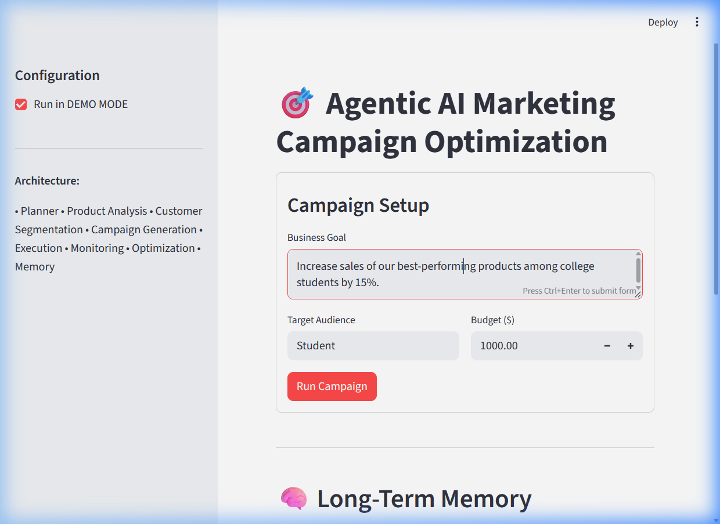Shows: Project title, DEMO MODE enabled, campaign goal, Target Audience: Student, Budget: $1,000, complete agent architecture in sidebar (Planner, Product Analysis, Customer Segmentation, Campaign Generation, Execution, Monitoring, Optimization, Memory).
__________________________________________________

Screenshot 2 — Product and Customer Intelligence
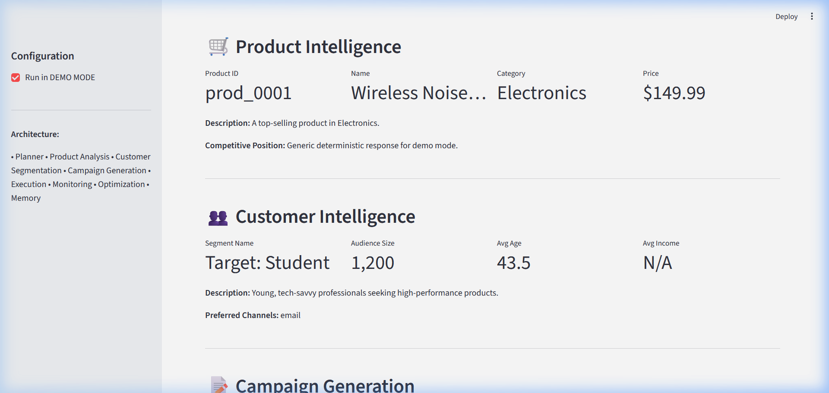Shows: Product Intelligence — prod_0001, Wireless Noise-Canceling Headphones, Electronics, $149.99. Customer Intelligence — Target: Student, Audience Size 1,200, Avg Age 43.5, Preferred Channel email.
__________________________________________________

Screenshot 3 — Campaign Generation
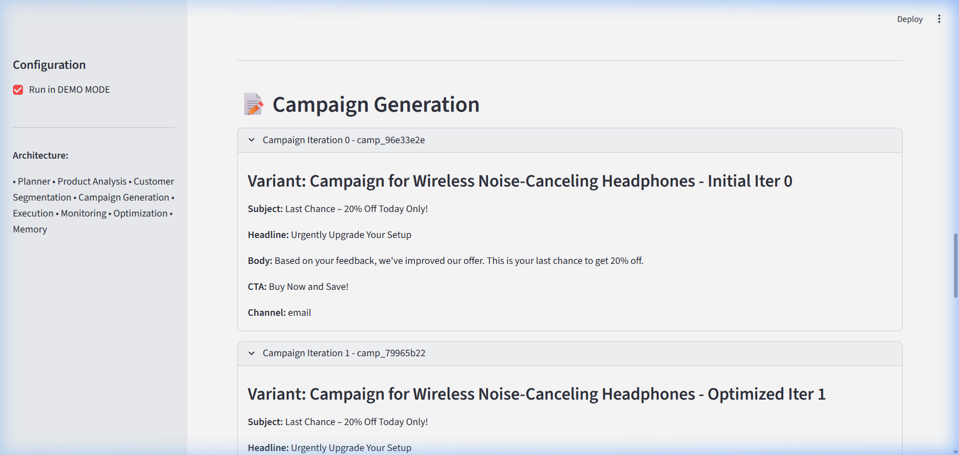Shows: Campaign Iteration 0 (Initial) and Campaign Iteration 1 (Optimized) with full content (subject, headline, body, CTA, channel).
__________________________________________________

Screenshot 4 — Campaign Performance and Primary KPI
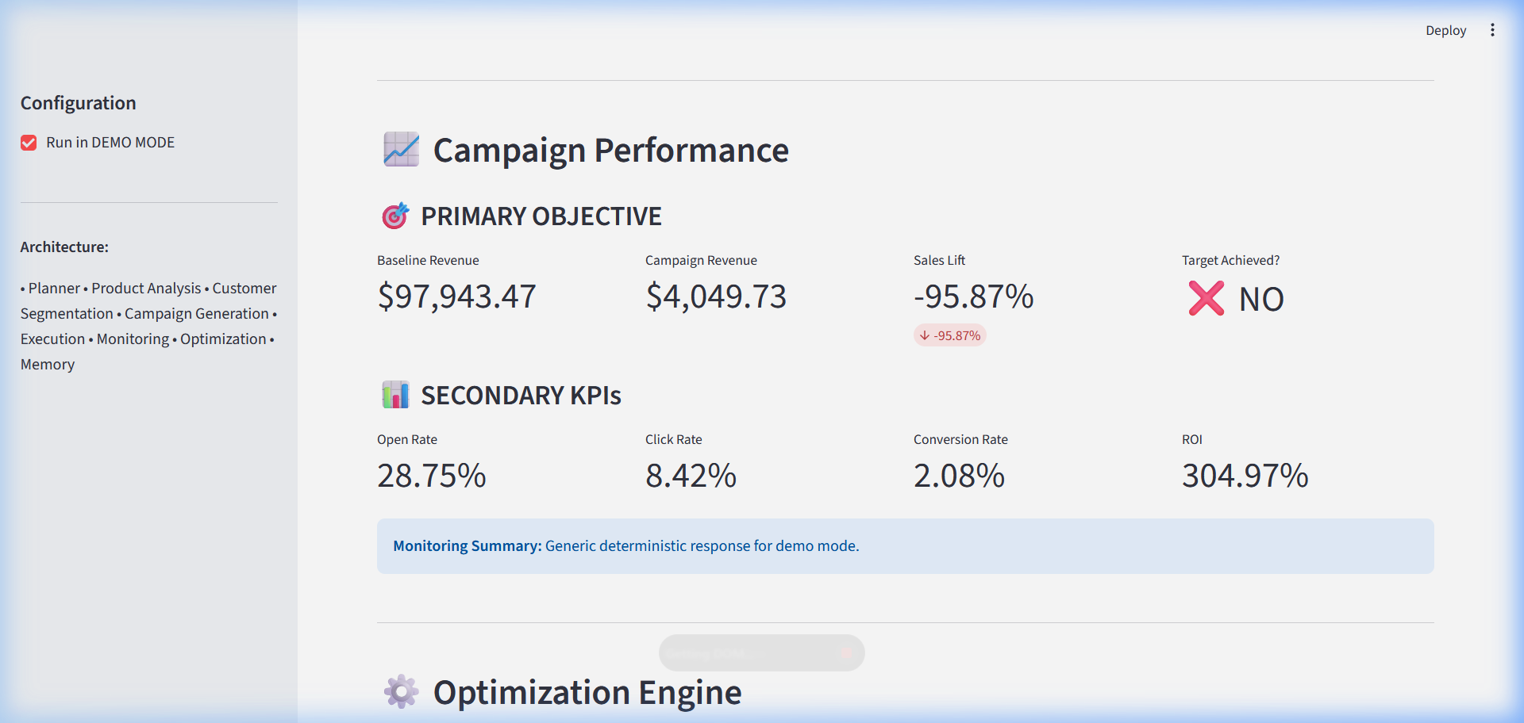Shows: PRIMARY OBJECTIVE — Baseline Revenue $97,943.47, Campaign Revenue $4,049.73, Sales Lift -95.87%, Target Achieved: NO. SECONDARY KPIs — Open Rate 28.75%, Click Rate 8.42%, Conversion Rate 2.08%, ROI 304.97%.
__________________________________________________

Screenshot 5 — Optimization Engine
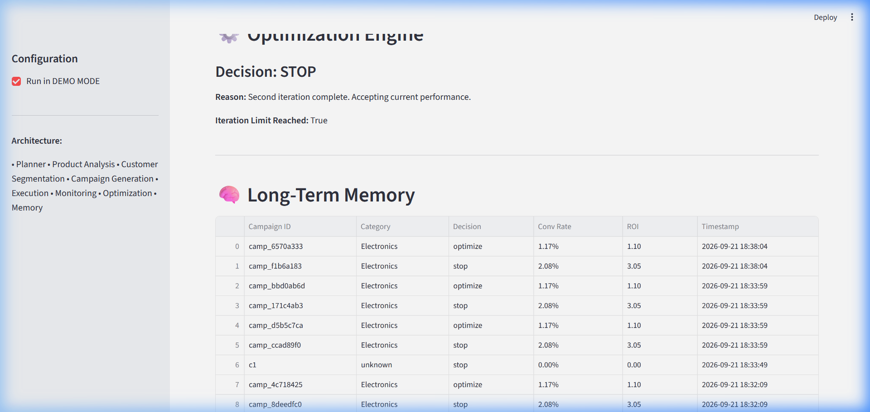Shows: Decision STOP, Reason "Second iteration complete. Accepting current performance.", Iteration Limit Reached True. Long-Term Memory table with 9 historical campaign entries.
__________________________________________________

Screenshot 6 — Long-Term Memory
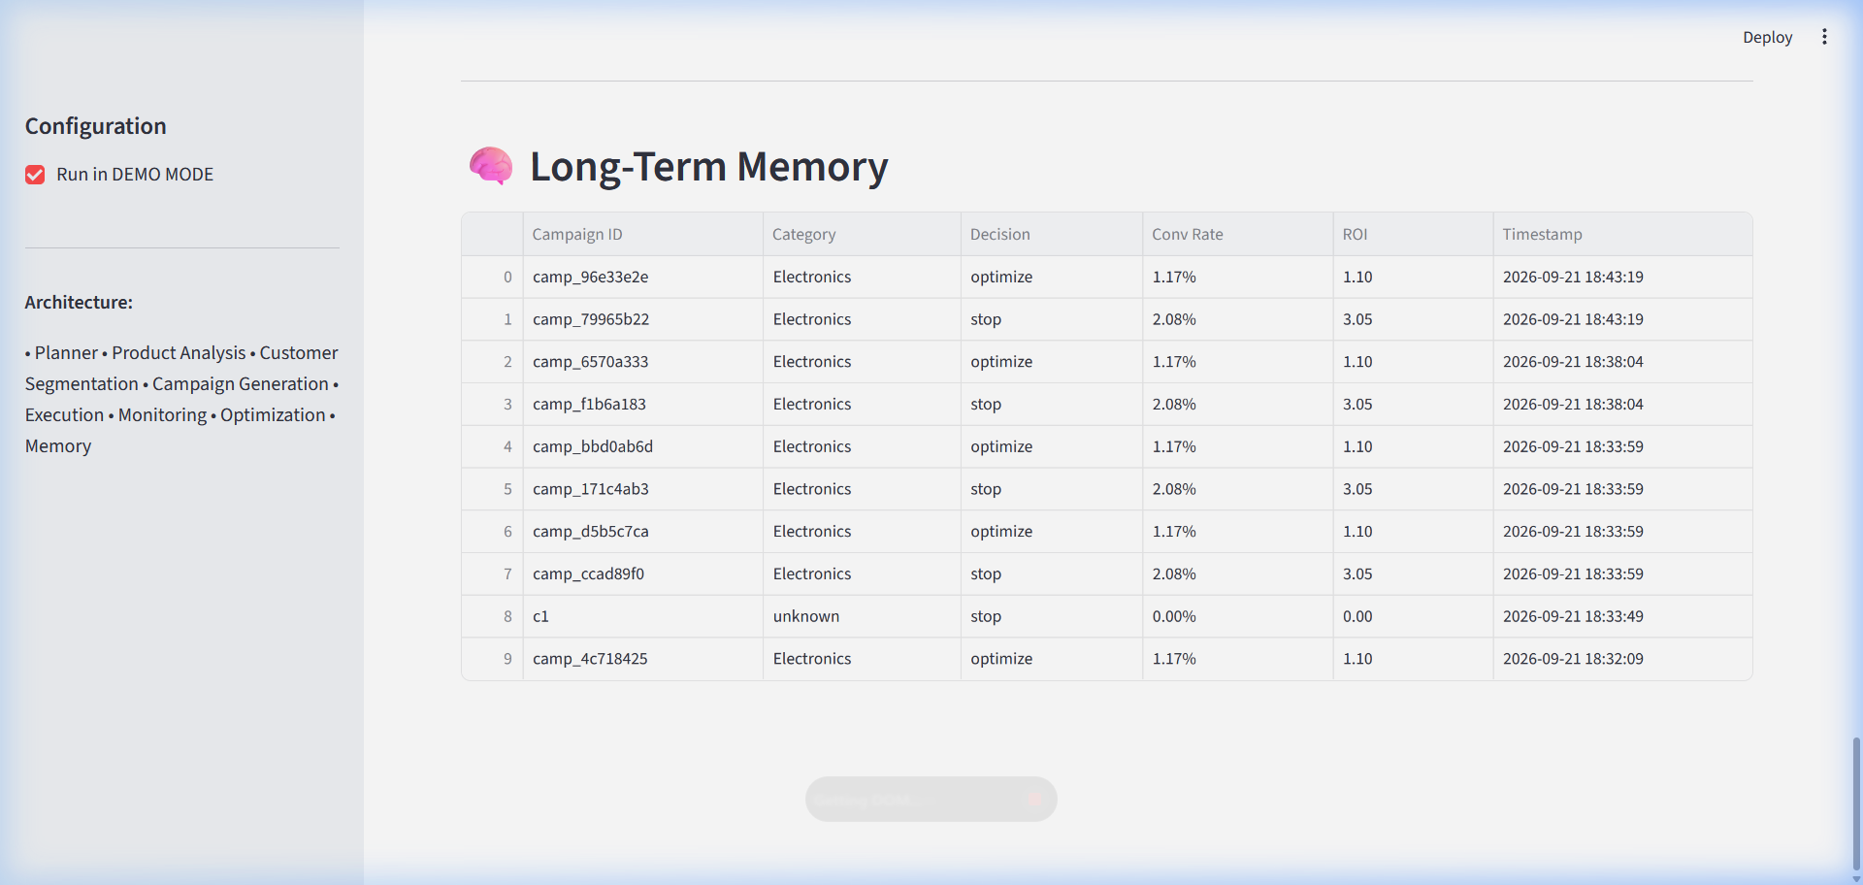Shows: SQLite long-term memory table with 10 historical campaign records from two workflow runs: Campaign ID, Category, Decision, Conv Rate, ROI, Timestamp.
__________________________________________________

23. Why This System Qualifies as Agentic AI
Agentic Property | Implementation
Task Decomposition | PlannerAgent decomposes the business goal into 6 typed, ordered `PlanStep` objects with dependency declarations
Specialized Agents | 7 distinct agents with non-overlapping roles — analyst, segmenter, copywriter, executor, monitor, optimizer, memory manager
Tool and Data Usage | Agents use Pandas, SQLite, and `DataService` to retrieve and compute real data — not hallucinated metrics
Shared Mutable State | `WorkflowState` (Pydantic model) is the single source of truth passed between all agents via LangGraph
LangGraph Orchestration | A compiled `StateGraph` enforces execution order and manages the conditional loop
Conditional Routing | The `should_optimize()` edge function evaluates runtime state to decide whether to iterate or terminate
Feedback Loop | The Optimization Agent's recommendation concretely changes the next campaign's content
Autonomous Optimization | No human approval is required between iterations
Long-Term Memory | SQLite-backed `MemoryStore` persists campaign outcomes across runs; the Campaign Generation Agent retrieves and uses this memory autonomously

Distinction from a chatbot: A chatbot responds to a single prompt. This system decomposes a high-level goal, selects tools, delegates tasks to specialized sub-agents, evaluates its own output, and autonomously refines its approach — without further human input after the initial goal is provided.
__________________________________________________

24. Limitations
Limitation | Description
Synthetic Dataset | 100 products, 1,000 customers, and 5,000 purchases generated with seed=42. Results may not generalize to real-world data.
Simulated Execution | No real emails or notifications are sent. The simulator uses deterministic probability functions.
DEMO_MODE Mock LLM | In DEMO_MODE, LLM responses are deterministic keyword-keyed strings. Real LLM quality would differ.
Ollama Runtime Not Verified | The live Ollama integration was code-verified but could not be executed — no active Ollama instance was available during final testing.
Baseline Comparability | Historical revenue ($97,943.47) is the total purchase history; campaign revenue is from a single execution against 96 customers. These are not over comparable time windows, making the sales lift figure a prototype comparison, not a statistically valid measurement.
Single Product, Single Segment | The current workflow selects one product and one segment per run.
No Real-Time Data | The system operates on a static synthetic snapshot.

__________________________________________________

25. Future Scope
- Real email delivery: Integration with providers such as SendGrid or Mailchimp.
- Real CRM integration: Connect to Salesforce or HubSpot for live customer data.
- Real-time campaign data: Stream live open/click/conversion events into the monitoring pipeline.
- Comparable time-window baseline: Measure baseline and campaign revenue over the same rolling period.
- Stronger semantic memory: Replace keyword-based retrieval with vector embeddings.
- Multi-channel campaigns: Orchestrate email, SMS, push, and social campaigns simultaneously.
- Advanced experimentation: Implement proper A/B testing with statistical significance testing.
- Multi-agent parallelism: Run product analysis and customer segmentation concurrently.
- Live Ollama verification: Deploy with a confirmed LLM endpoint for end-to-end LLM-driven reasoning.
__________________________________________________

26. Conclusion
This project successfully implements a production-quality academic prototype of an Agentic AI Personalized Marketing Campaign Optimization System using Python, LangGraph, Pandas, SQLite, Pydantic, Streamlit, and Plotly.
The system demonstrates all required agentic AI properties: a Planner Agent decomposes a high-level business goal; seven specialized agents carry out analysis, generation, execution, monitoring, and optimization; all agents communicate through a shared typed state; LangGraph orchestrates the workflow with conditional routing; and a SQLite-backed memory store allows agents to learn from previous runs.
The primary KPI — revenue/sales lift — is calculated from real synthetic purchase data as a historical baseline. The optimization loop demonstrably improved ROI from 109.99% to 304.97% across two iterations, while conversion rate remained steady at 2.08%, driven by the CTA change the Optimization Agent recommended between iterations.
The full test suite comprises 56 tests with 0 failures, covering agents, workflow, analytics, data integrity, edge cases, revenue consistency, and Streamlit runtime. All screenshots are captured from the live running application.
The system demonstrates that a network of specialized AI agents, working in coordination with deterministic data tools and persistent memory, can autonomously optimize a marketing campaign from initial goal to iteratively refined outcome — without human intervention between iterations.
__________________________________________________

